Warehouse Extension
This document contains the procedure for Warehouse Extension for a single material.
In the URL, click on ‘Material Processing’ àWarehouse Extension, enter the material code for which warehouse is to be maintained and click on ‘ continue ‘.
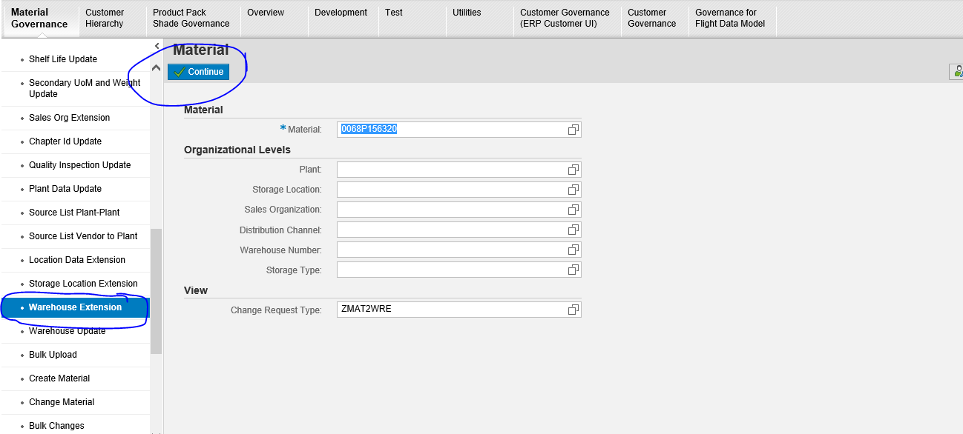
Click on ‘Edit’. Click on ‘Add’ under ‘Warehouse Extension’. A box with the available warehouses get displayed. Select the warehouse and click on ‘Add’ in the box.
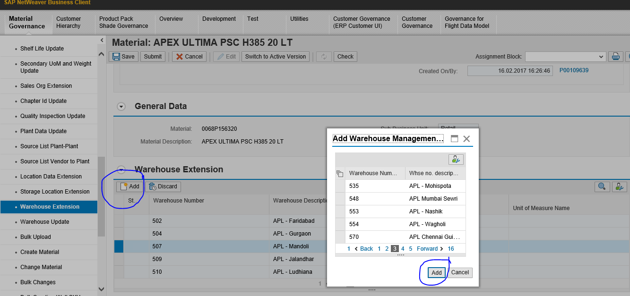

After selecting the warehouse, click on ‘Check’ at the top of the screen. Only on getting ‘ no errors found’ , should you be clicking on the ‘submit’ icon.
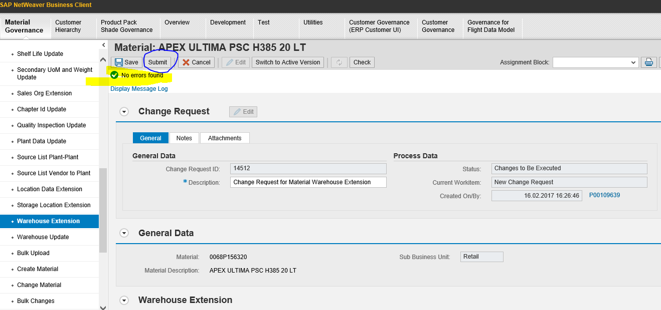
On clicking on the ‘submit’ icon, you will get the change request number.
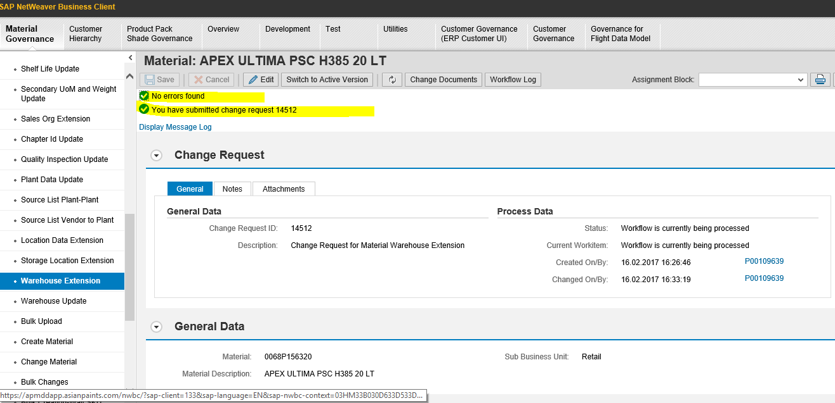
You may check in the target system ie; in Production for the desired change after about 15 minutes. Incase the required change does not reflect in Production, log an incident. Do not forget to mention the change request number in the incident.

------ E N D ------

